North Lincolnshire Council
Daily Event Analysis
17th October 2010

Overview
The Low Santon TEOM measured a daily mean PM₁₀ concentration of 60µg/m³ on Sunday the 17th October 2010 exceeding the allowed 50µg/m³ as a daily mean. A check of the data has revealed that concentrations of PM₁₀ increased sharply between 08:00 & 10:00 as did the Osiris and then again between 11:00 & 17:00 in which the concentrations at the TEOM were higher than the Osiris. Between 08:00 & 10:00 the Osiris peaked at 235µg/m³ and the TEOM at 191µg/m³. Between 11:00 & 17:00 the TEOM recorded an average concentration of 89µg/m³ whereas the Osiris measured an average concentration of 38µg/m³.

Met Conditions
Consistent SW winds were observed throughout the day. The wind within the early morning period of focus ranged between 171° and 239°. Wind speeds averaged at 1.1 m/s. After 11:00 wind speeds averaged at 2.6m/s. No rain was measured throughout the day.

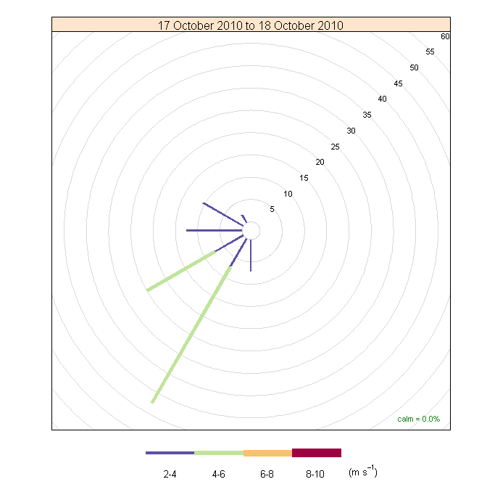

Episode Wind Range 08:00 to 10:00

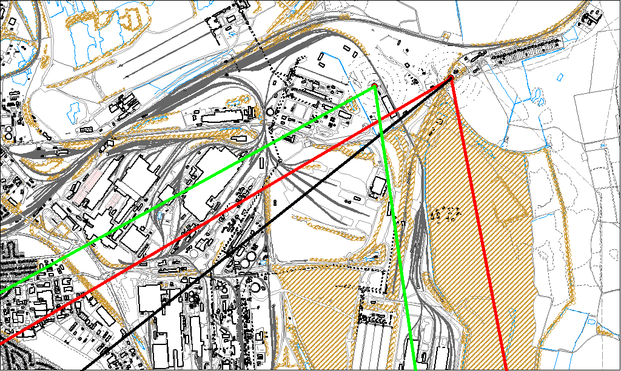

Potential Sources
The above map shows the Low Santon Monitoring Station (indicated by the red lines) and the DLCO Osiris (indicated by the green). The black line within the red shows the wind direction of the highest concentration during the 2 hour period of focus.

The Osiris & the TEOM both spiked during this period. It is likely that the source of the event originated between point in which the lines intersect and cross-over. Although the wind range was large for this short period it covers an area which is consistently identified as potentially adding to the PM₁₀ issue.

The likely areas include;

- The Redbourn Steel Stocking Area
- The Intermediate Site
- The Ore Beds

The black line indicates the highest measured concentration during this period. This runs through the Redbourn Steel Stocking Area. Could activities during this period be investigated at the Redbourn Steel Stocking Area.

Episode Wind Range 11:00 to 17:00
As the day was subject to a second period of elevated levels the TEOM and Osiris were compared. The TEOM measured an extended period of non-compliance whereas the Osiris saw a reduction in its levels and returned to lower levels.

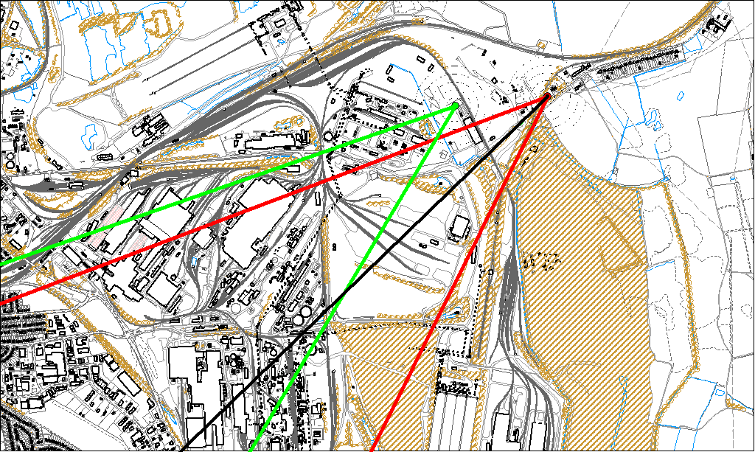

Potential Sources
The above map shows the Low Santon Monitoring Station (indicated by the red lines) and the DLCO Osiris (indicated by the green). The black line within the red shows the wind direction of the highest concentration during the 6 hour period of focus.

As the Osiris was not subject to the same elevated levels as the TEOM, it is likely that the source of the episode did not originate from within the wind sectors relevant to the Osiris (green lines). By removing the area of wind affecting both the Osiris & TEOM we can identify specific areas on site that may have been responsible for the exceedance.

The likely areas include;

- The Redbourn Steel Stocking Area
- The Intermediate Site
- The Slag Haul Road.

The black line indicates the highest measured concentration during this period. This runs through the Redbourn Steel Stocking Area.

